BP 1865 thenahimananas@yahoo.co.uk Bujumbura www.hopeinburundi.org
Burundi Tel: 00 257 22225706
East Africa Honda: + 257 76663500
Libby: + 25775844000
3rd May 2022

NAHIMANA’S NEWS
Dear Friends,
It’s hard to believe that after 3 years in Burundi, the whole Nahimana Family will be returning to the UK for 2 months. We are so excited about this up-coming trip! If anyone would like to see us during this time, please contact me asap, so that I can get some dates in our diary before we leave…
Restoration of Hope:
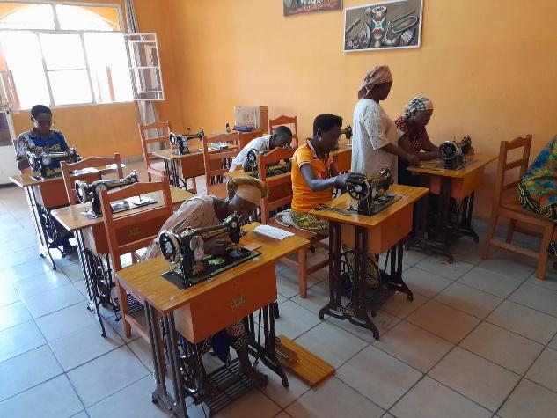
In March 2022 we received the first 10 women who will be trained for a year in sewing skills These women have between 1-6 children and survived by either begging or prostitution. To be able to give them the opportunity to gain the skills and equipment to set up their own business is such a privilege. The total cost to train and equip 10 women for a year is £3250/ $4,225 or £325 per woman. If anyone would like to contribute for the next group of women in 2023, just let us know.
We were contacted by a friend in America to ask if Honda had any new projects up his sleeve that he was wanting to start. Honda came up with 4 projects which had the potential to change lives and transform the futures of people we care for – this is always Honda's heart.
Helping the sewing project women: The money we will receive will enable us to buy each woman a bed and mattress, clothes for themselves and their children, and set them up with a small income generating business that they can run in the afternoon when not at the sewing centre – for example making and selling donuts or roasting and selling peanuts and other small snacks. This will be transformational for the 10 families these women represent.
Building an annex at Via’s House: We will build an annex comprising 3 small units, 2 of which Via could rent out and 1 that she could use as a small boutique (shop), as a way of generating income to provide for the family’s needs.
Setting up a soap-making factory: Unemployment is a huge problem here and those who finish school are struggling to find jobs. Creating employment is the only way forward. Gafirimbi was one of the first boys that we put through school and technical college many years ago. He learnt all the skills needed to produce soap and so will be able to be our trainer, teaching other members of the RoH family about soap manufacture and providing them with employment.
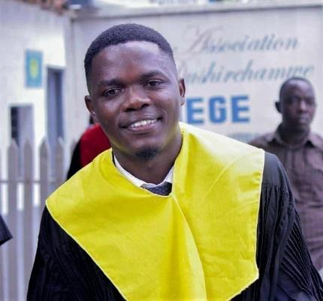
Education: Vincent finally had his graduation ceremony and is now qualified in Entrepreneurship and Economics. Help us pray that he will find a job soon, to be able to put his qualification to good use.
Thank you so much for your support; we just paid third-term fees for 137 children and young people sponsored by Hope in Burundi to continue their education.
Prayer Points:
- In March, the decision was made to ban all motorbikes, tuk-tuks (3-wheeled motorised taxis) and bicycles from the city. Over 24,000 people who were drivers of these forms of transport, lost their jobs. The knock-on effects are disastrous! People who were already struggling to feed their family are now literally starving. Please pray for a reversal of this decision.
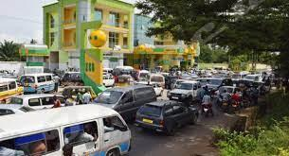
- The petrol shortages that had been an issue since August are now unbelievable. People park their vehicles in queues at petrol stations in the afternoon in the hope that the next day there may be fuel. Please pray that this issue can be sorted, as it adds to the increased cost of all transport and of spiralling goods prices.

- Sugar has been widely unavailable for purchase since December. If a shop manages to get a few kilos, there will be queues down the street of people desperate to buy it. It is bizarre because sugar is one of Burundi’s main cash crops. Please pray that whatever the issue is, it gets resolved asap.

- Please pray for God to provide all the finances needed for the 137 children and young people we are putting through school and university. The total needed is expected to come to around £17,000/$22,000.
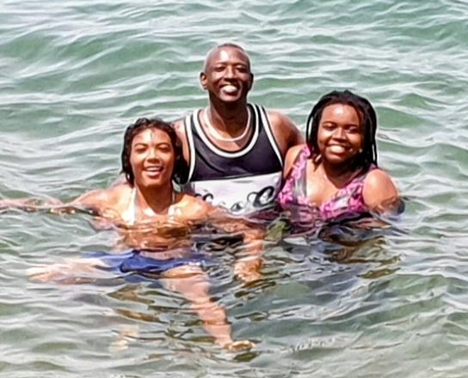
Nahimana Family News:
Josiah has had a pretty rubbish time of it for the last 2 school holidays. A week before Christmas he tested positive for Covid, and although not too ill, was quarantined in his bedroom to avoid infecting anyone else. Thankfully he was testing negative on Christmas Day, so made it out to eat lunch with the rest of us. He had been having issues with his left knee for some time. A trip to the hospital revealed he had Patellar Tendinopathy, which meant no sports for at least a month and 15 physiotherapy sessions. So hopefully by summer he will be back to full strength and willing to play anyone who is available at basketball!
Abigail is studying A-level Geography, Psychology and Sociology online and will need to return to the UK next summer as those subjects are being examined through an Oxford-based school. She would like to go to university but doesn't have the ability to study in the UK like Betha and Josiah unless International Student fees are paid – this is prohibitive. Please pray that we have wisdom to know what is next for Abigail.
In her first year studying Nursing at Birmingham University, Bethany's first placement was in an orthopaedic trauma ward during the Covid pandemic, and dealing with patients dying was quite a challenge. She is incredibly empathetic and way more sensitive than me, so feels people's pain very deeply. Her present placement is in the mental health sector, which again is pretty overwhelming. Recognising that not every client can be helped using the resources available to practitioners is giving her food for thought. We are very much looking forward to spending time with Bethany over the summer.
As well as overseeing Restoration of Hope, Honda is kept busy with his shops and with helping various members of the community. His watch shop continues to do well, but getting new stock is a real challenge. Hopefully in the summer he will be able to buy new stock to bring back for his shop.
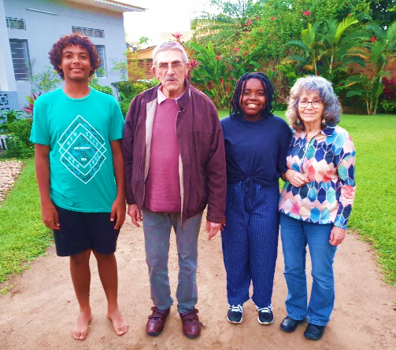
Thank you so much to those who have continued to pray for me. I am definitely doing much better than I was 6 months ago. I still have issues with getting very breathless and dizzy when doing cardio exercise (because of the residual effects of Coronavirus not through being unfit!) which is frustrating, but remembering how ill I was, I just have to be thankful for the progress I have made. Working out helps me physically, mentally and emotionally because the gym is usually a place of laughter too and I am very grateful for the friends in the UK who pay for our gym memberships.
In February it was wonderful to welcome my parents back to Burundi for the first time in 4 years. Three times during their visit our minivan broke down and had to go into the garage. When you are an hour and a half drive up into the mountains with no garages or recovery vehicles anywhere, your prayers become more heartfelt than normal!
I was blown away when my parents were contacted by their friends who said they felt God telling them to give us a generous gift for personal use, and to cut a very long story short, we have now ordered a second-hand Toyota Noah MPV from Japan, which should hopefully arrive before we fly to England. God is a generous Father, who loves all of His children and is not limited in His resources!
We couldn't do this without you! Looking forward to catching up with as many of you as possible in the summer.
Much love,
Honda, Libby, Bethany, Abigail, Josiah and all our extended RoH Family XXX
If anyone would like to support the work of Restoration of Hope this can be done via our UK registered charity, Hope in Burundi (charity number 1151062). The bank account details are as follows:
Bank: CAF Bank Ltd
Account Name: Hope in Burundi
Sort Code: 40-52-40
Account Number: 00024118
For those who would like to Gift Aid their donation, please contact Vic Ford – e-mail drvford@yahoo.com or 01283 214407 to request a Gift Aid form.

